**MATLAB PART**

1. *“BianchiTheory.m”* and “*myfun1.m”* matlabfiles should be in the same folder

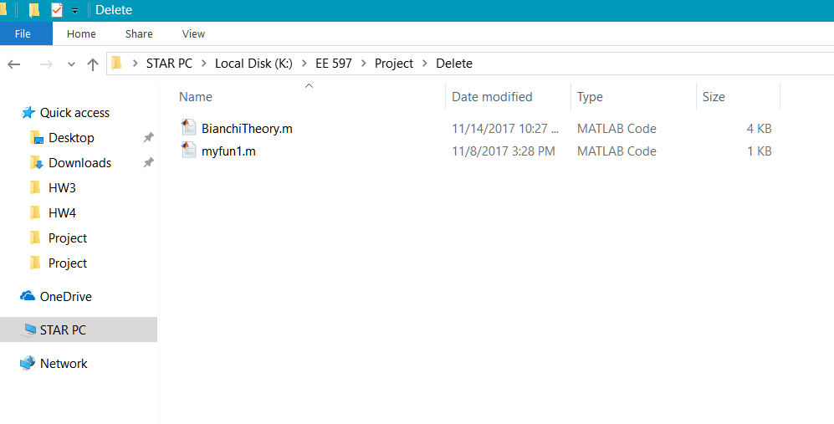

1. Run *“BianchiTheory.m”.* You will get two graphs (One for Pcollision and one for saturation throughput) for three back-off window size cases.

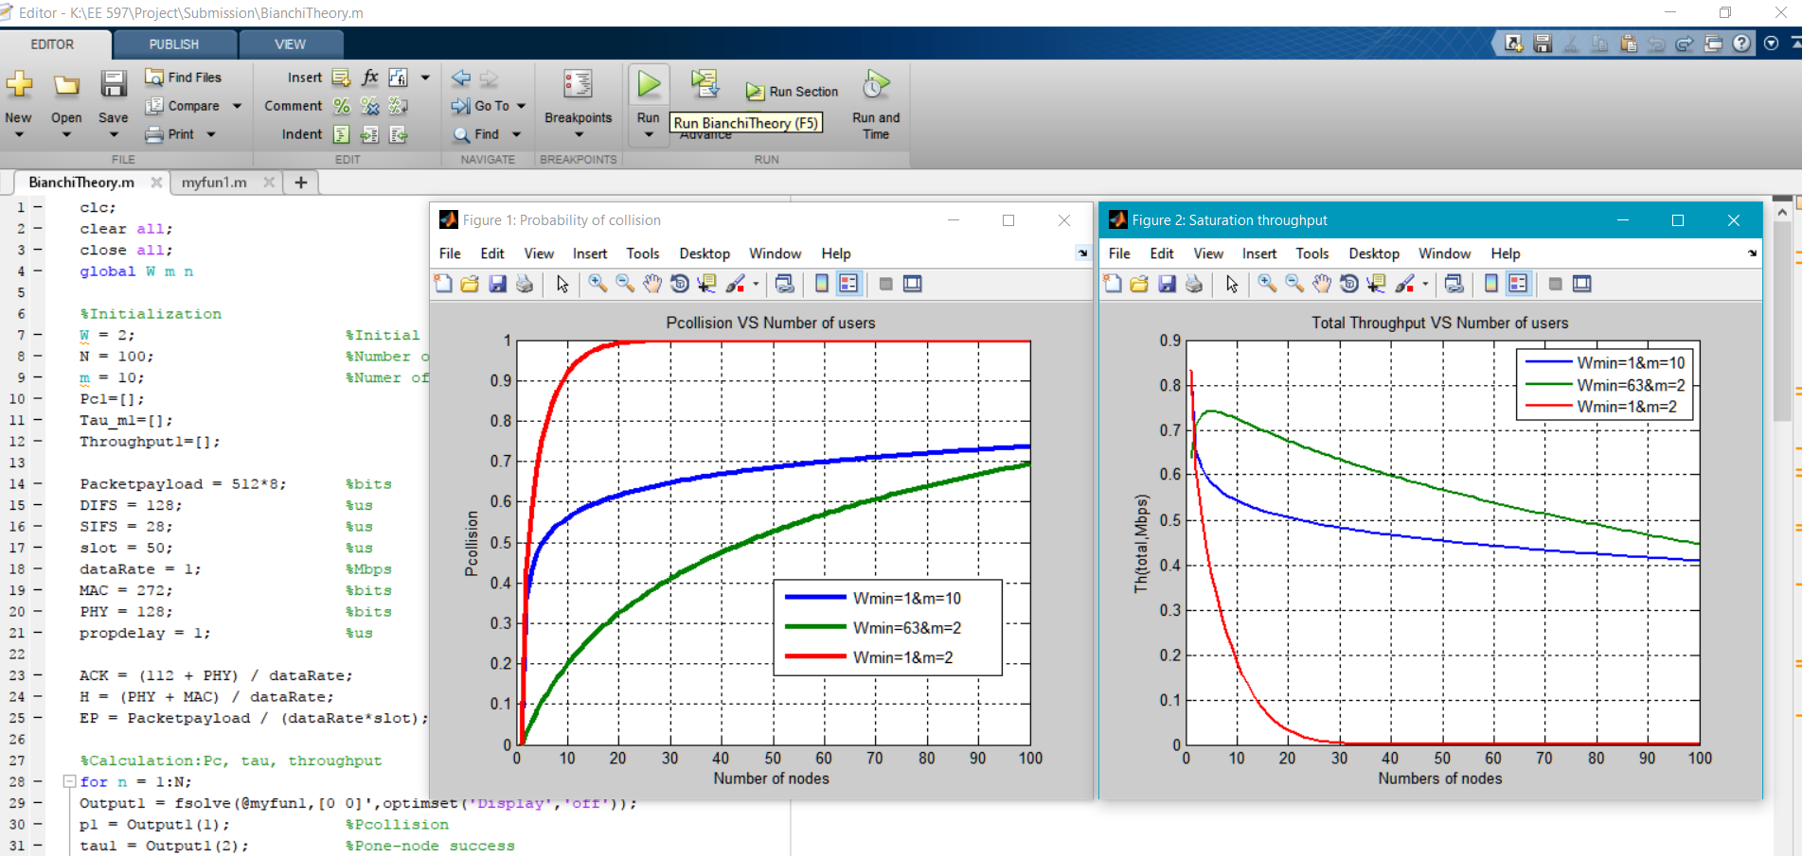

**NS3 PART**

1. After placing the myProject.cc file in the scratch folder, if you run the following command from ns-3-dev folder, the simulation will run. The following images shows the output for nWifi = 20, Wmin = 63, Wmax = 127.

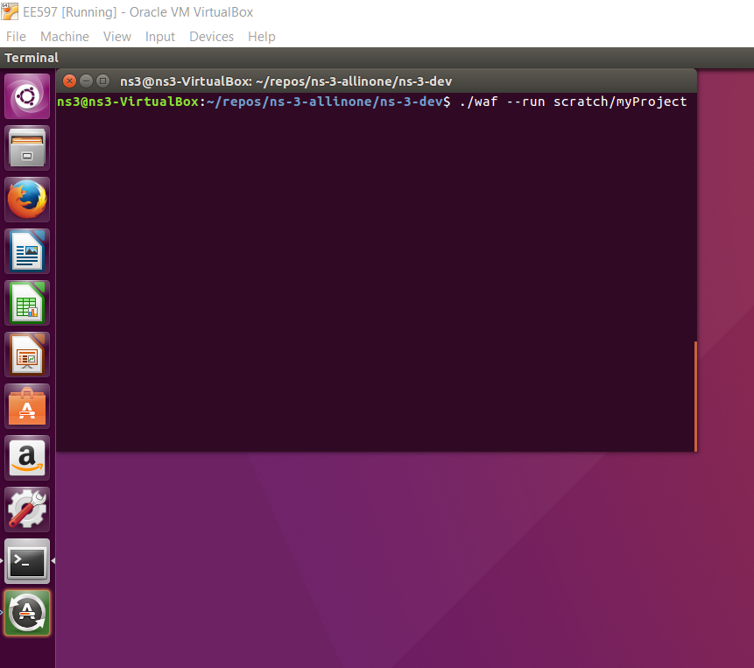

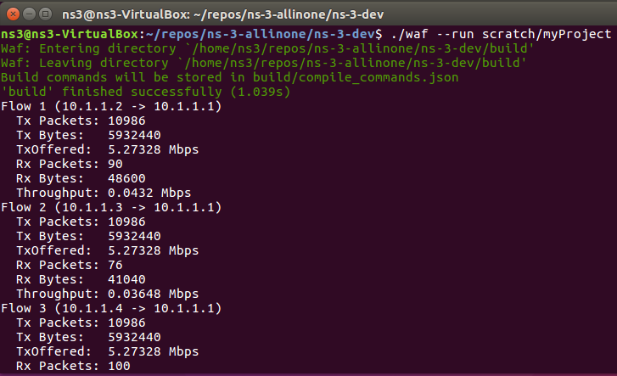

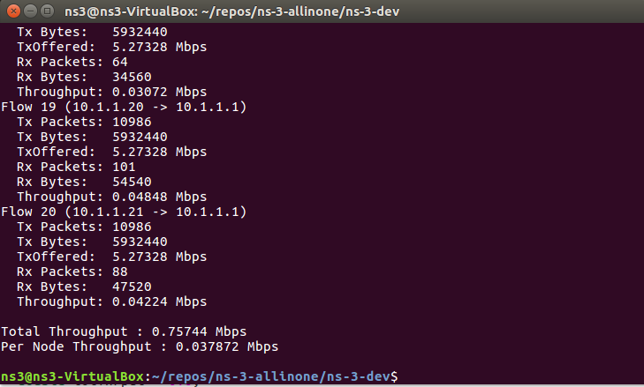

1. If you want to change the number of nodes, change the following parameter in the code.

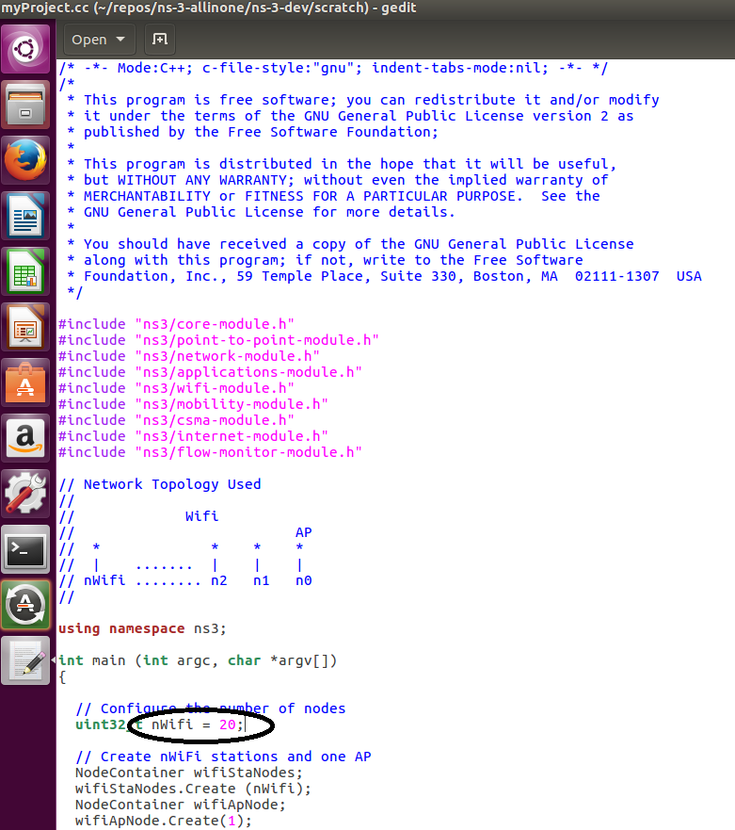

1. If you want to change the Wmin and Wmax values, change the following parameters in the code.

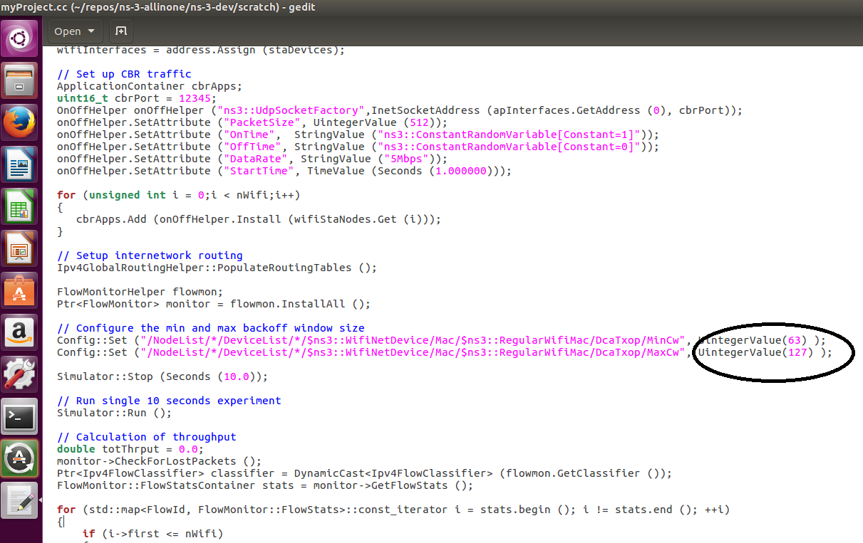

1. If you want to change the data rate of the nodes for a fixed number of nodes, change the following parameter in the code.

